DealLinks

Your onestop biz portal

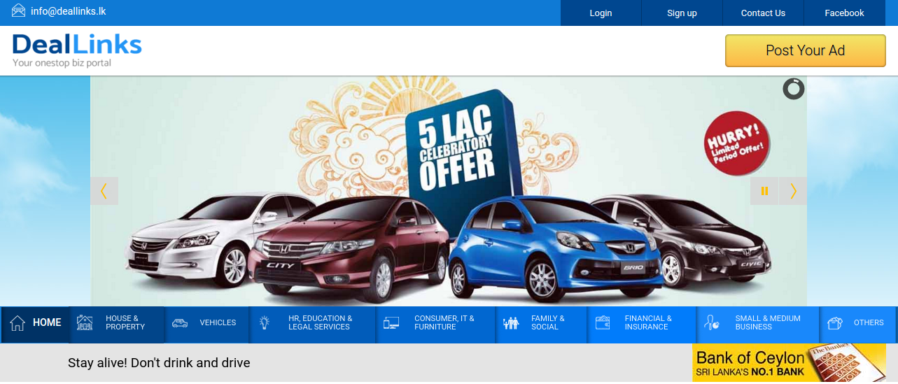

Featured Document
Version 1.0

Content Management System
Joomla! 3.7.0

Prepared By

Procons Infotech (Pvt) Ltd
# 171-2/1, Nawala Road, Nugegoda, 10250, Sri Lanka.
W - www.proconsinfotech.com
T - +94 112 199 555/+94 114 378 580 | F - +94 114 209 555

Table of Contents
1.1 How to log in to the system 3
1.2 How to logout from the system 4
2.0 Dashboard 5
2.1 User Accounts 5
2.2.1 Manage User Account Details 6
2.2 Property Advertisements 7
2.2.1 Gold Images (Featured Images) 7
2.2.2 Manage Property Advertisements 9
3.0 Category and Forms Handling 10
3.1 Manage House Property 11
3.2 Advertisement Main Category 13
3.3 sub Category 14
3.4 Districts 15
3.5 Manage Vehicle Category 16
3.6 Manage Vehicle Facilities 17
3.7 Manage Vacancy 18
4.0 Slideshows 19
4.1 Main Slides 19
4.2 Paid Advertisements 22
4.3 Instructions 25

1.0 How to Access Joomla! Content Management System

1.1 How to log in to the system
In order to log in to the CMS of your organization’s web site you have to enter the following address in the browser.
http://deallinks.lk/administrator/
Upon successful loading of the page you will see the following screen (Fig. 1.1). In the login form of the page type the user name and the password provided to you and click on “Login” button to enter into the CMS.
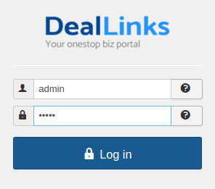

Fig. 1.1 – CMS Login Page of the Website
If you login successfully you will see the “Dashboard” of the CMS of the website as shown below in (Fig. 1.2)
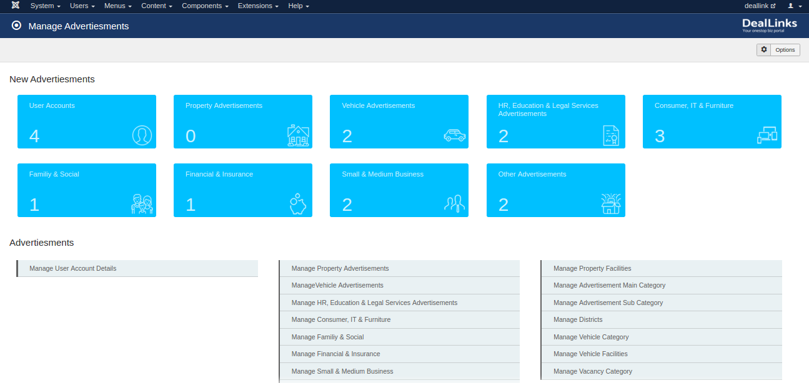
Fig. 1.2 – CMS Home Page of the Website
The main content of the dashboard is discussed in detail in below chapters.

1.2 How to logout from the system
In the top right hand corner of the window next to Website preview link, you will see a dropdown list as shown below in Fig. 1.3. Click on “Logout” so as to logout from the system.

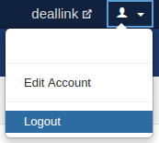

Fig. 1.3 - Log out using Site >> Logout in main menu of CMS

2.0 Dashboard

2.1 User Accounts
In order to access new user accounts go to the dashboard of “DealLinks”, then click on the “User Accounts” named Box, which is made clear in the below (Fig 2.1).
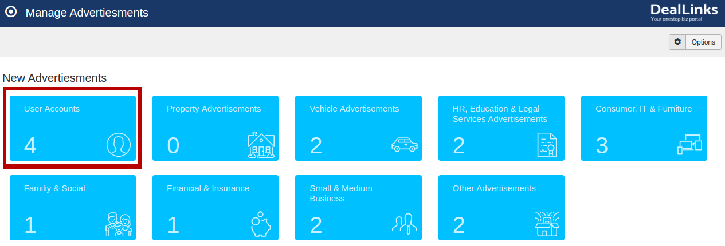
Fig. 2.1 – Display of “User Accounts” Dashboard Menu Selection
Once you click on it, you will be able to access following section.
Note: Here are the newly added ones only will display. if suppose there is not any advertisement , the section will be blank.
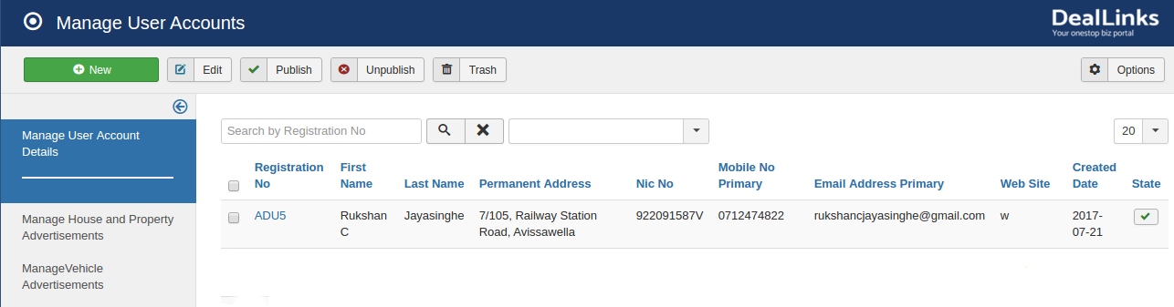
Fig. 2.2 – Display of Newly Added “User Account Detail”
Note: Once the user placed their details into the DealLink fronend signin process. The data will be stored in the backend. At the same time, the user will receive feedback screen with an “Accessible Link” through email to set their account. After that process only the particular user account will be confirmed.

2.2.1 Manage User Account Details
You can check existing and newly added account list all together, once clicking on this below shown highlighted dashboard menu (Fig 2.3)
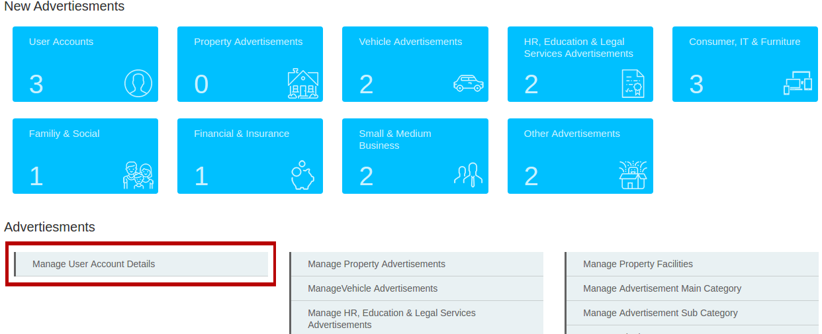
Fig. 2.3 – Display of Selection of “Manage User Account Details”
If you select once, the following “User Accounts” will be appear under “All Advertisement” dropdown session.
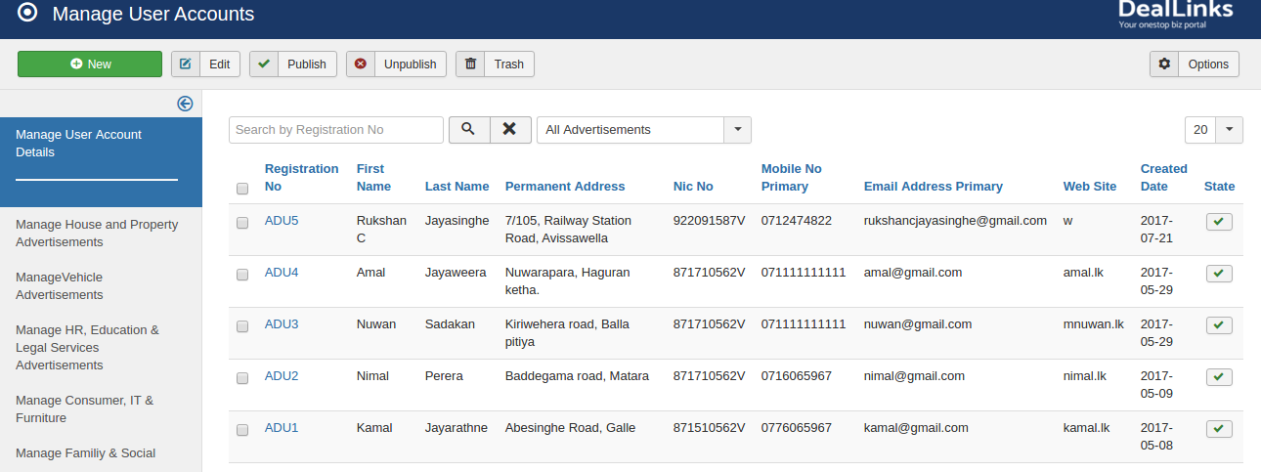
Fig. 2.4 – Display of Accounts Listdown
Note: You can check particular account, while clicking on the “Registration Number”.

2.2 Property Advertisements
In order to access property advertisement, go to the dashboard of “DealLinks”, then click on the “Property Advertisements” named Box, which is made clear in the below (Fig 2.5).
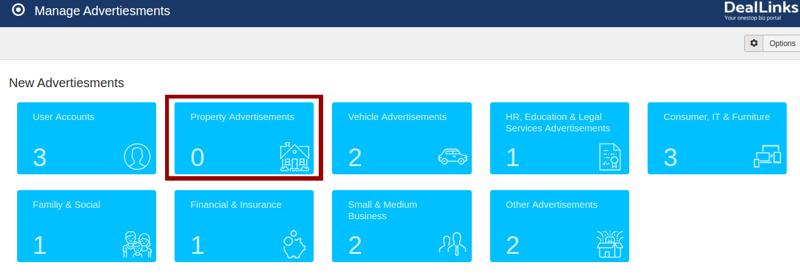
Fig. 2.5 – Display of “Property Advertisements” Dashboard Menu Selection
Once you click on it, you will be able to access following section.
Note: Here are the newly added ones only will display. if suppose there is no any advertisement, the section will be blank.
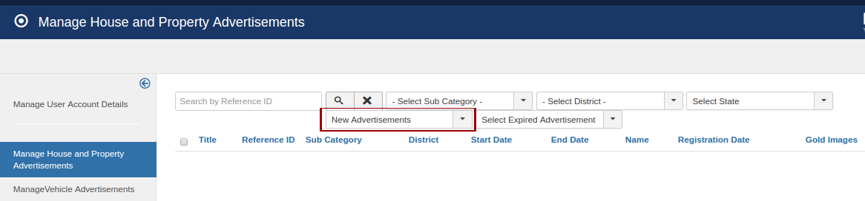
Fig. 2.6 – Display of New “Advertisements” Section

2.2.1 Gold Images (Featured Images)
In order to add fixed featured images in particular page, simply click on “View All” link of the “HOUSE & PROPERTY” box in home page.
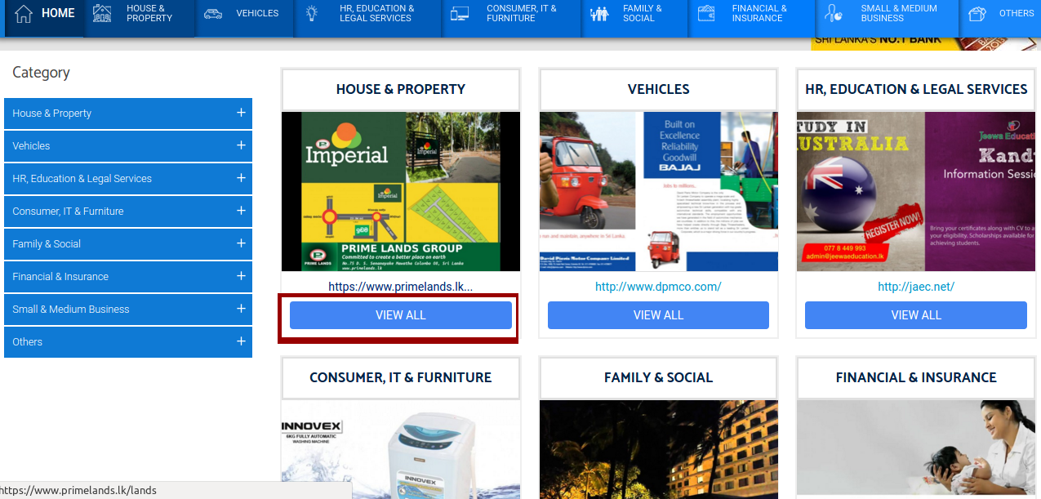
Fig. 2.7 – Display of House & Property's Link to Enter
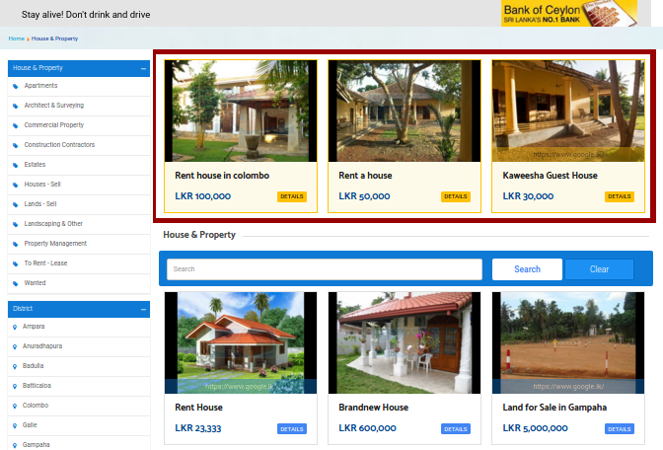
The following detailed page will be appeared with featured images on top of the page. Which is made clear in the below (Fig 2.8)
Fig. 2.8 – Display of Featured Images in frontend
Note: This “Golden Featured Images” doesn't effect with random changes. It always appears on top of the page. You can positioned this featured image while puts a tick in check box in the back end, there is a restriction that you can add 3 only at a time, which is made clear in the below (Fig 2.9)
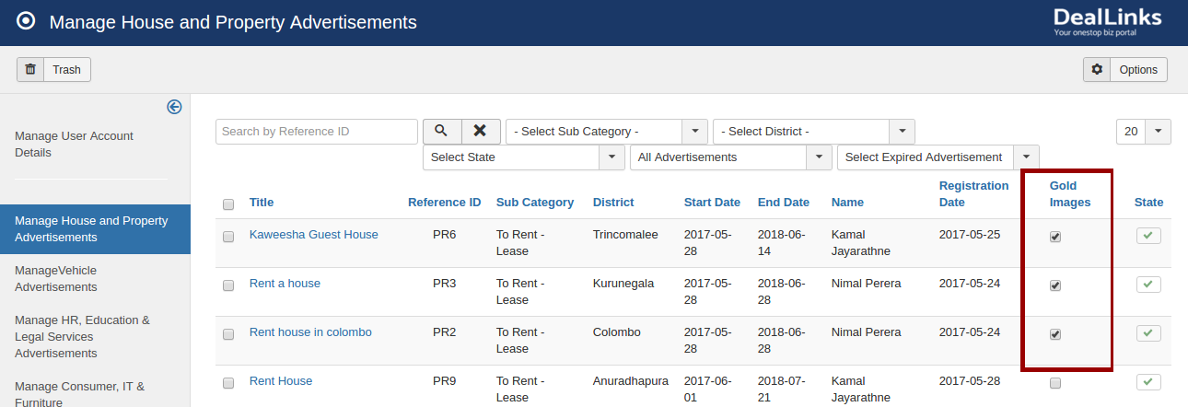
Fig. 2.9 - Display of Selection of Featured Images

2.2.2 Manage Property Advertisements
You can check existing and newly added account listdown all together, once you clicking on this highlighted option.
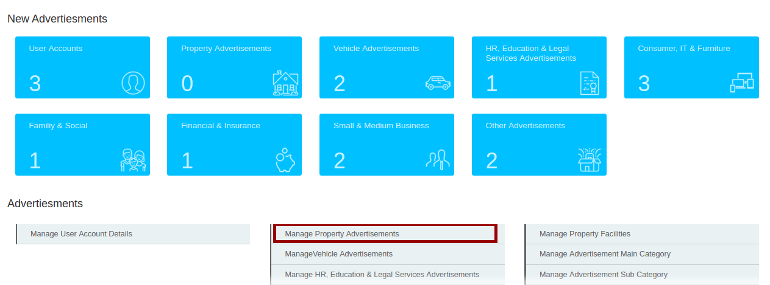
Fig. 2.10 – Display of “Manage Property Advertisements” Dashboard Menu Selection
If your selection has been made, the following “Property Advertisement” will be appear under “All Advertisement” dropdown session.
Also, the dropdown options will assist you to filter required data as you want to check.
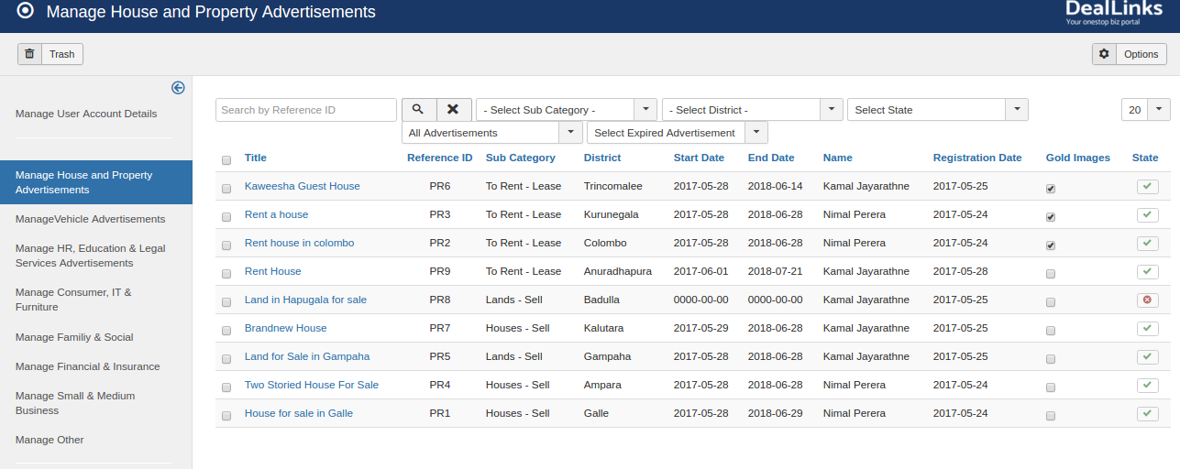
Fig. 2.11 – Display of Property Advertisements Listdown
Note: The other dashboard menus also have the same steps like above shown format. For clear clarification purpose only, some components have been explained briefly. You can see whole components in above (Fig 1.2).

3.0 Category and Forms Handling
As an admin you can check component menus has been placed on the right. Which is highlighted within the red box (Fig 3.1)
- Backend
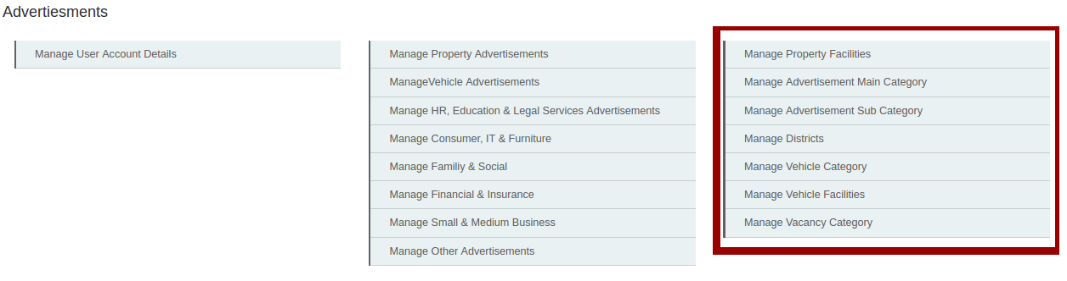
Fig. 3.1 – Display of Dashboard Menus
- Frontend
Order to check this related sections in frontend, first you should “Login” to the system in the frontend. Then you will be able to access following (Fig 3.2) dash board.
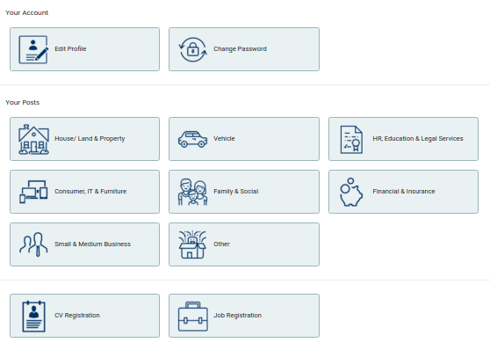
Fig. 3.2 – Display of Dashboard in Frontend

3.1 Manage House Property
- Frontend
In order to access Manage House & Property section, simply click on “House/ Land & Property” box in dashboard (3.2)
Then click on a button called New “House & Property Registration”. Which is displayed in right of the screen (Fig 3.3).
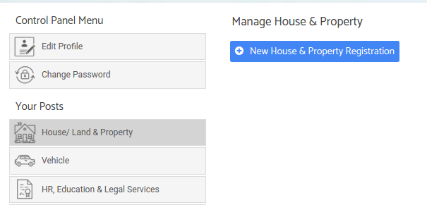

Fig. 3.3 – Display of Add New “House & Property Registration”
If you click on above shown button, the selection will be successfully redirected to the below shown screen (Fig 3.4)
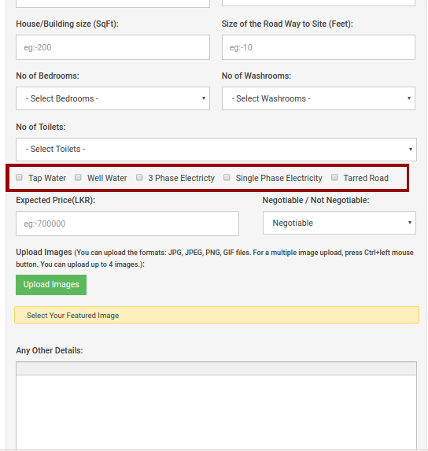

Fig. 3.4 – Display of Property Facilities in Frontend Form

- Backend
above shown check boxes contains some mutual facilities, you can put ticks as you wish. you can see those in backend, under manage property facilities.The selection is made clear (Fig 3.5)
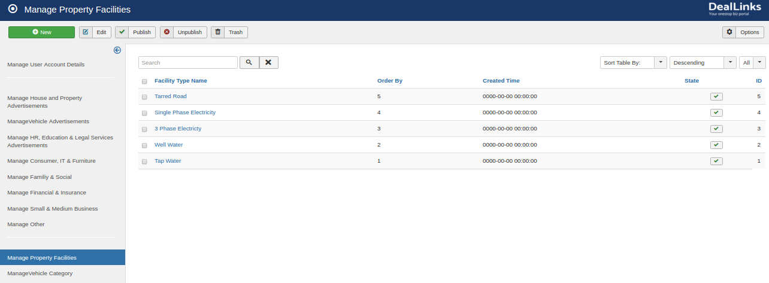
Fig. 3.5 – Display of Property Facilities in Backend Dashboard

3.2 Advertisement Main Category
The user can access following category (Highlighted with a red box) in home page without any restrictions. These main categories will be added in the backend by admin panel.
- Front end
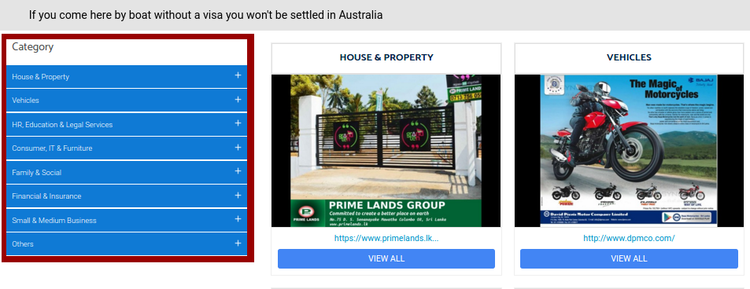
Fig. 3.6 – Display of Main Categories in Home page
- Back end
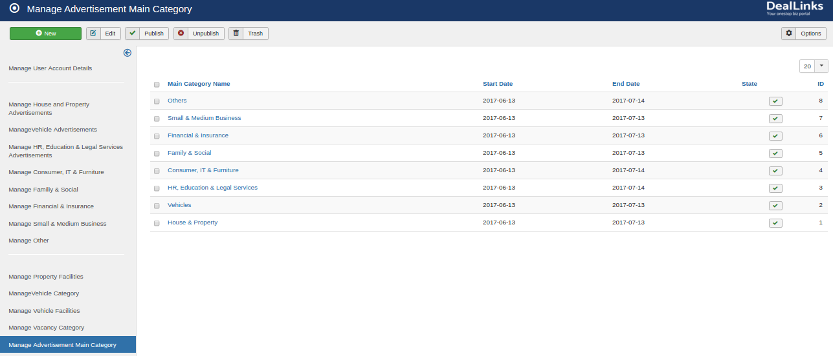
Fig. 3.7 – Display of Main Categories in Backend
In this category creation session, you should add main categories in two places, one is under above shown “Dashboard Menu” area. Another one should come under “Main Menu” section.
Note: You don't need to create sub categories in both ways. Once you have added sub categories under the back end dashboard, it will automatically display in both areas.

3.3 sub Category
The user can access following sub categories (Highlighted with a red box) under Main category in home page without any restrictions. These sub categories will be added in the backend by admin panel.
- Front End
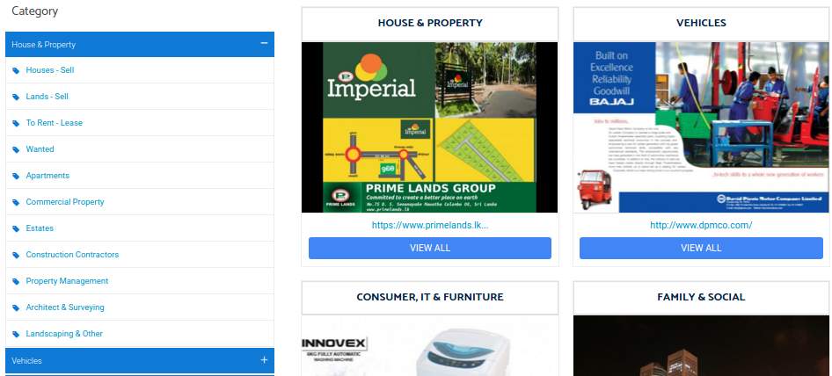
Fig. 3.8 – Display of Sub Categories in Home page
- Back end
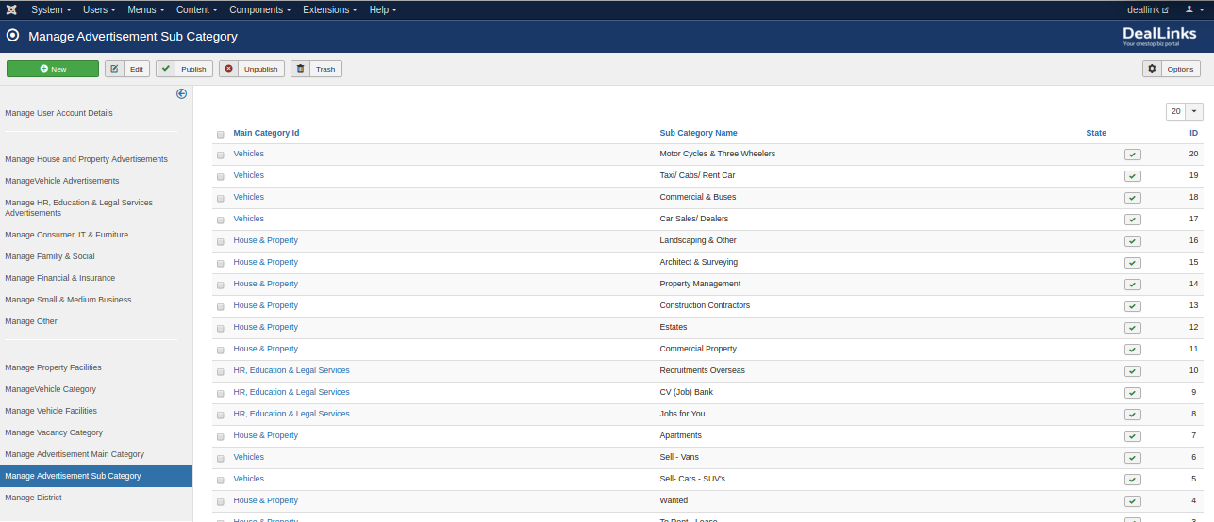
You can check this sub category under the backend dashboard menu called “Manage Advertisement Sub Category”.

Fig. 3.9 – Display of Sub Categories in Backend

3.4 Districts
You can access Other Registration form through “Other” named menu from frontend dashboard (Fig 3.2). Then click on “New Other Registration” button to access following screen. Here you can select “Sub Category” and “District” accordingly based on your requirement.
- Frontend
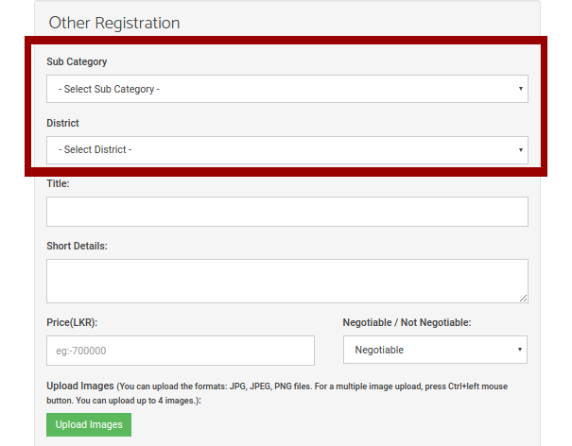

Fig. 3.10 – Display of Districts Dropdown in Frontend Form
- Back end
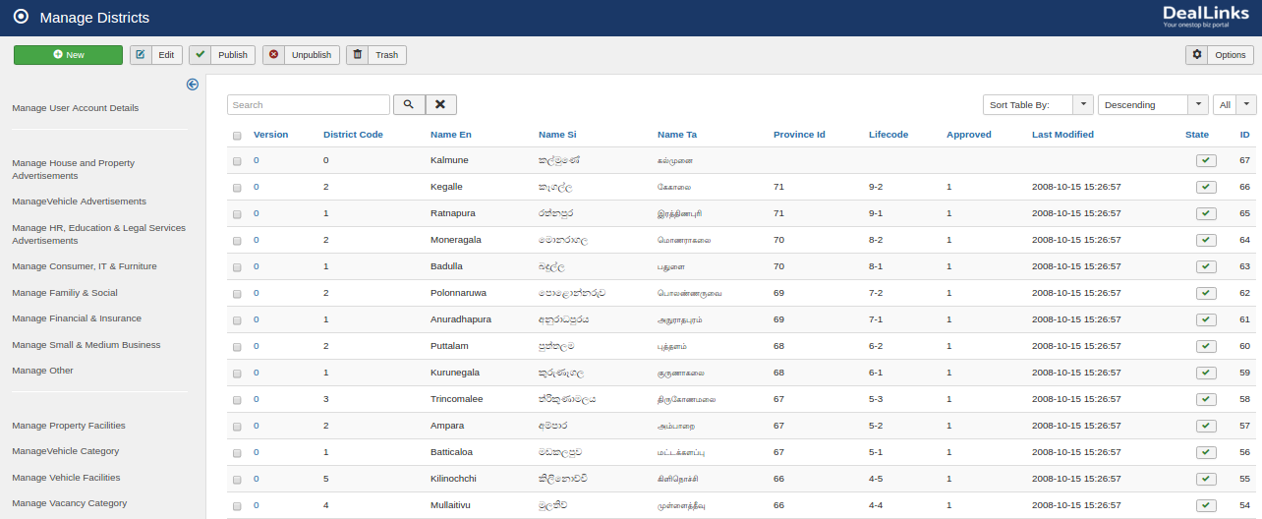
you can check those 25 districts over here in backend.
Fig. 3.11 – Display of Districts in Backend

3.5 Manage Vehicle Category
In order to handle vehicle category, you can access through “Vehicle” named menu from the frontend dashboard. Then click on “New Vehicle Registration” button to access following screen. Here you can see that there is 3 type of vehicle displayed under “Select Vehicle” dropdown. Which is made clear in the below (Fig 3.12)
- Frontend
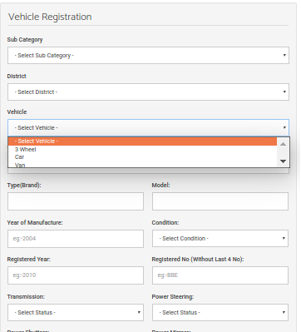

Fig. 3.12 – Display of Vehicle Category Dropdown in Frontend Form
- Backend
You can access same category lists in backend under “Manage Vehicle Category” dashboard menu.
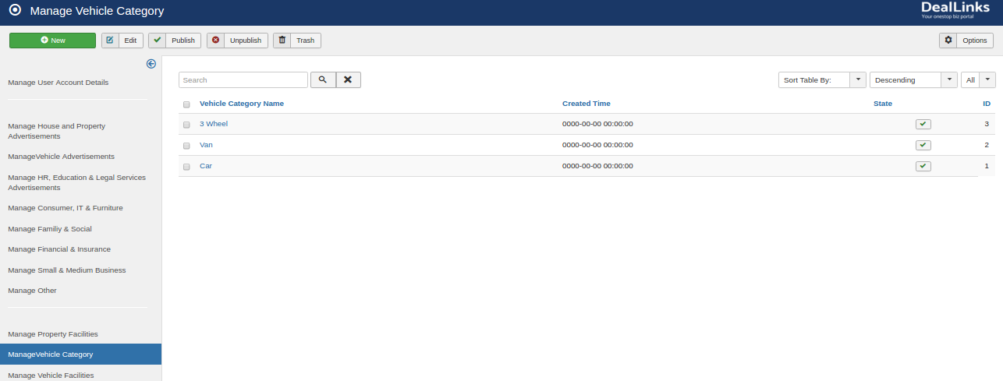
Fig. 3.13 – Display of Vehicle Category List in Backend

3.6 Manage Vehicle Facilities
In order to handle vehicle facilities, you can access through “Vehicle” named menu from the frontend dashboard (Fig 3.2). Then click on “New Vehicle Registration” button to access following screen. Here you can see that there are 3 check boxes available to select a facility with ticking process. Which is made clear in the below (Fig 3.14)
- Frontend
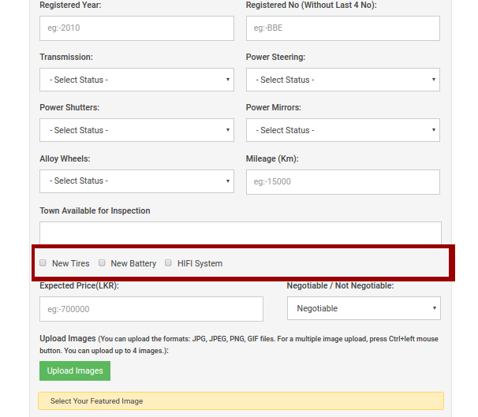

Fig. 3.14 – Display of Vehicle Facilities Check Boxes in Fronend Form
- Backend
You can access same facility lists in backend under “Manage vehicle Facilities” dashboard menu.
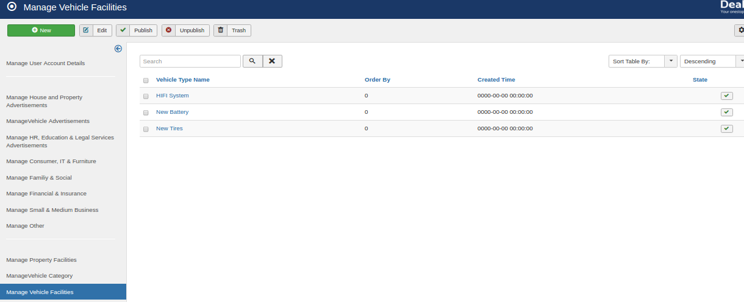
Fig. 3.15 – Display of Vehicle Facilities List in Backend

3.7 Manage Vacancy
In order to handle Job Vacancies, you can access through “Job Registration” named menu from the frontend dashboard (Fig 3.2). click on it to access following screen. Here you can select vacancy category from below shown dropdown. Which is made clear in the below (Fig 3.16)
- Frontend
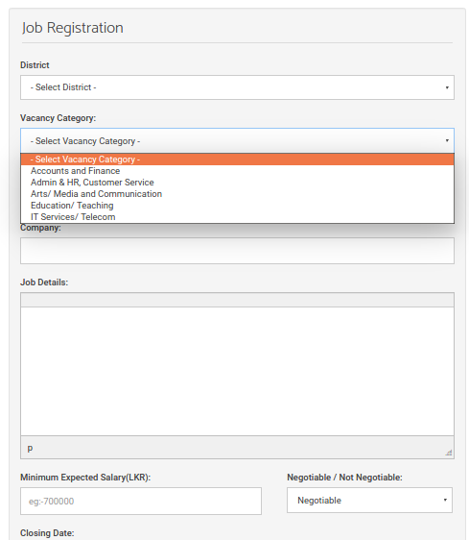
Fig. 3.16 – Display of Vacancy Category Dropdown Selection
- Backend
You can access same facility lists in backend under “Manage Vacancy Category” dashboard menu.
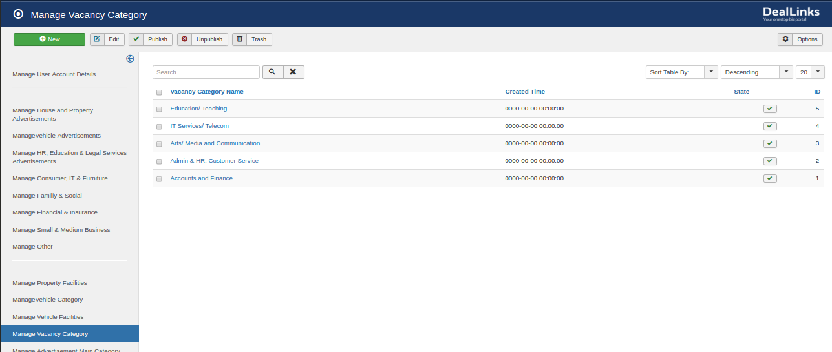
Fig. 3.17 – Display of Vacancy Categories in Backend
Note: As an admin, you can add few more fields if you needed to update in this above shown whole backend process.

4.0 Slideshows

4.1 Main Slides
Fig. 4.1 – Main Slideshow(W1024 x H330) in the Home Page
Once you click on “Extensions”, there is an option called “Module”.
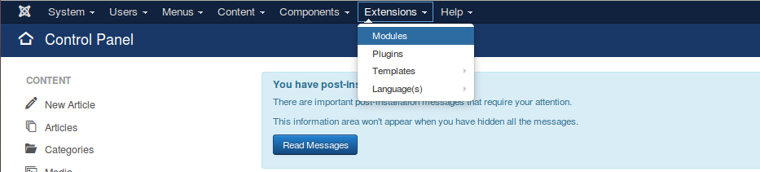
Fig. 4.2 - Display of Modules
Into that find out the module called “Main Ad Slideshow”. Which is made clear (Red Highlighted box) in the below (Fig 4.3) screen.
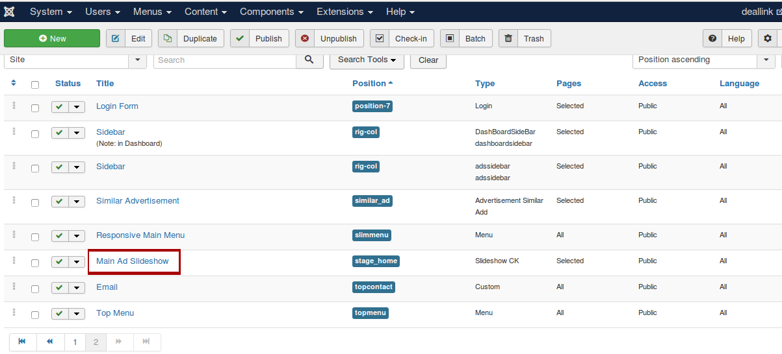
Fig. 4.3 – Display of Main Ad Slideshow selection
This “Main Ad Slideshow” facilitates you to manage the Main sliders in the home page of the website. You can access the edit facilities while clicking on the selected option.
Once your selection is made, you will be able to access following screen. Here you should select an option called “Slides Manager”. Which is made clear in the below (Fig 4.4).
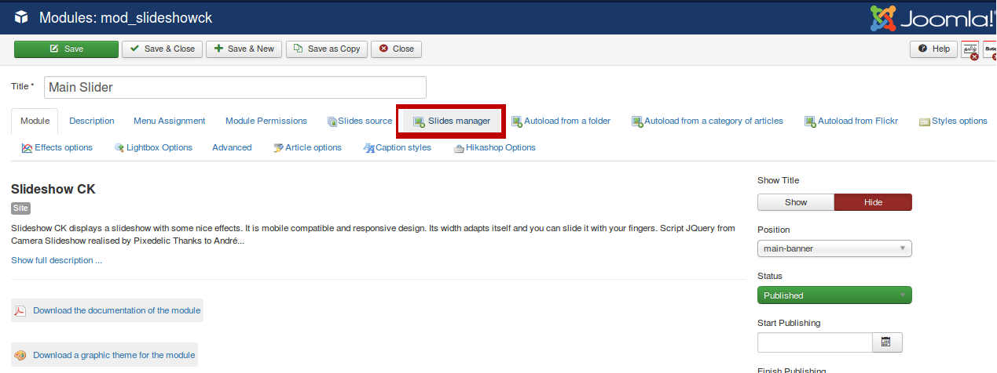

Fig. 4.4 - Display of Slides Manager selection
After clicking on “Slides Manager” option, you can see the following slider Items (Fig 4.5). Along with editing Facilities (4.6)
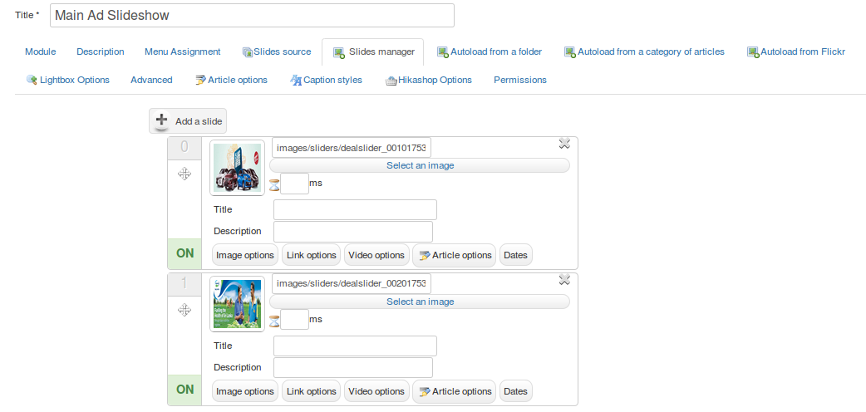

Fig. 4.5 – Display of the Slider Item
In the below window, There is an Option called Add Slide, then you can select “new” image, add it as a “new slide”,

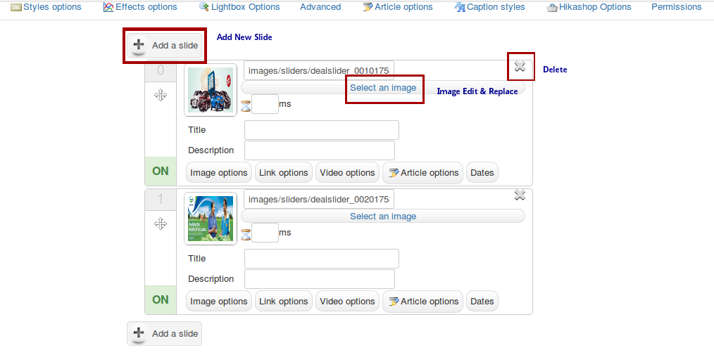
Fig. 4.6 – Display of the Slider with editing facilities

4.2 Paid Advertisements
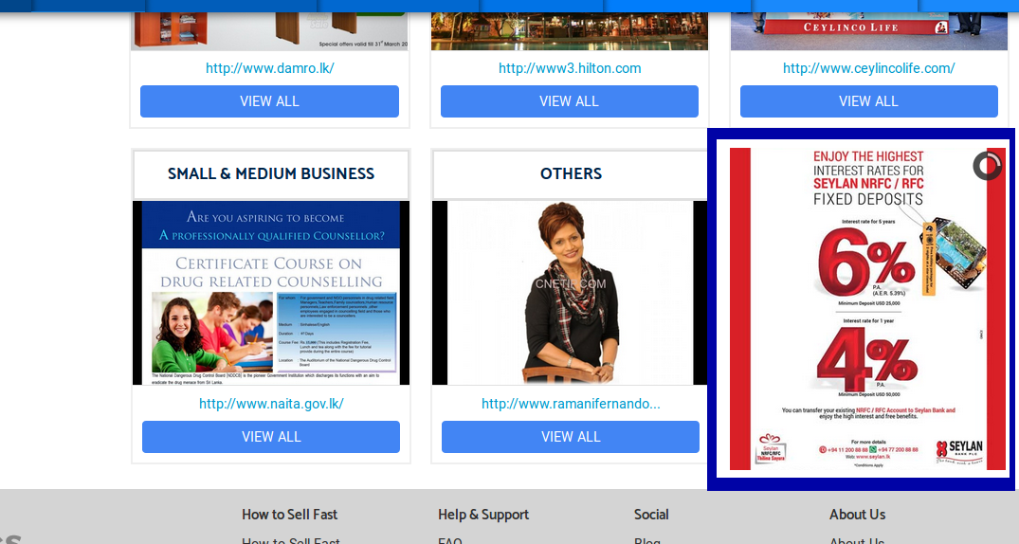
Fig. 4.7 – Paid Ad view (W300 x H340) in the Home Page
Once you click on “Extensions”, there is an option called “Module”.
Fig. 4.8 - Display of Modules
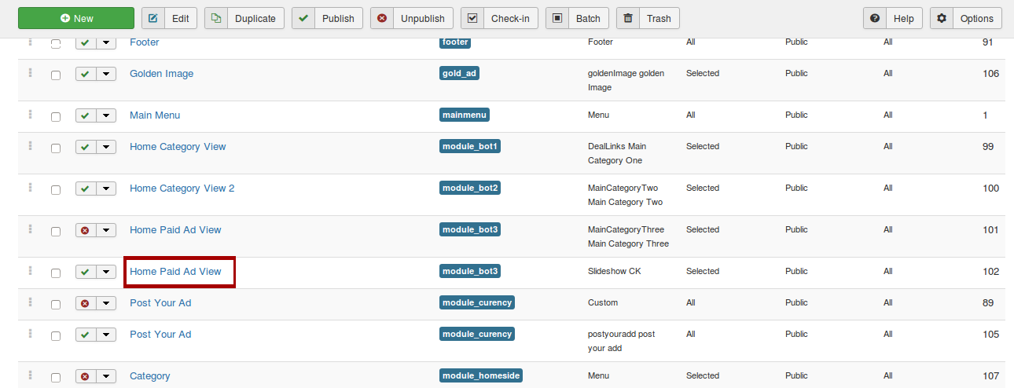
Into that find out the module called “Home Paid Ad view”. Which is made clear (Red Highlighted box) in the below (Fig 4.9) screen.

Fig. 4.9 – Display of “Home Paid Ad view” selection
This “Paid Ad view” facilitates you to manage the paid add in the home page of the website. You can access the edit facilities while clicking on the selected option.
Once your selection is made, you will be able to access following screen. Here you should select an option called “Slides Manager”. Which is made clear in the below (Fig 4.10)
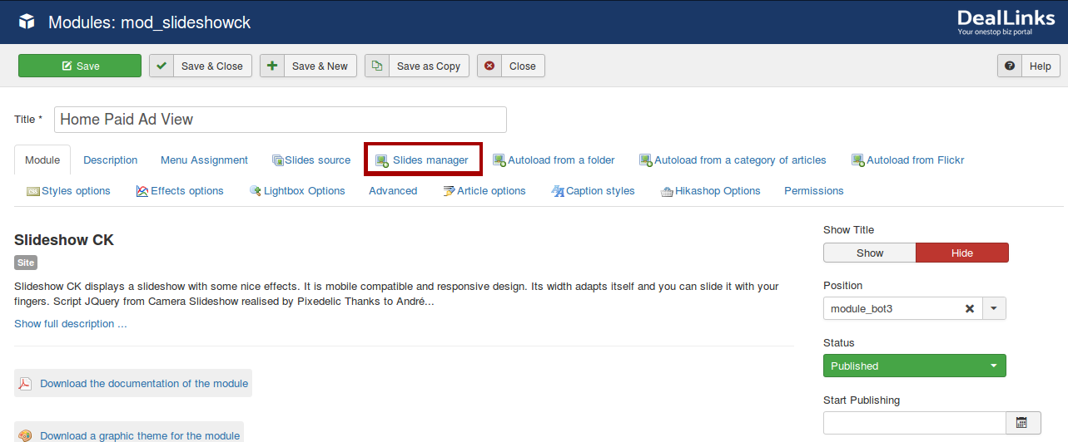
Fig. 4.10 - Display of Slides Manager selection
After clicking on “Slides Manager” option, you can see the following slider Items (Fig 4.11). Along with editing Facilities (4.12)
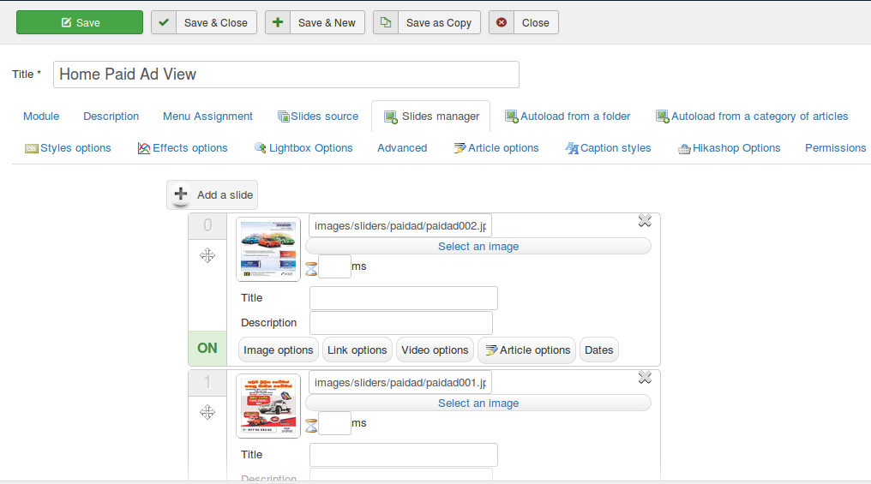

Fig. 4.11 – Display of the Slider Item
In the below window, There is an Option called Add Slide, then you can select “new” image, add it as a “new slide”,
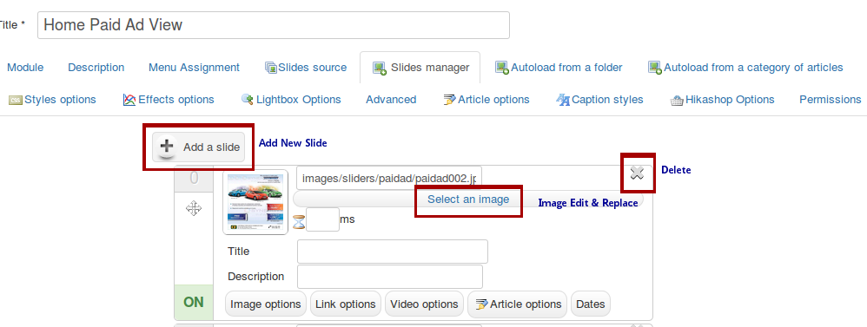

Fig. 4.12 – Display of the Slider with editing facilities
Note: This paid advertisement scale sizes should be considerable.

4.3 Instructions
You can check that the below red highlighted area contains some instructions along with the image.
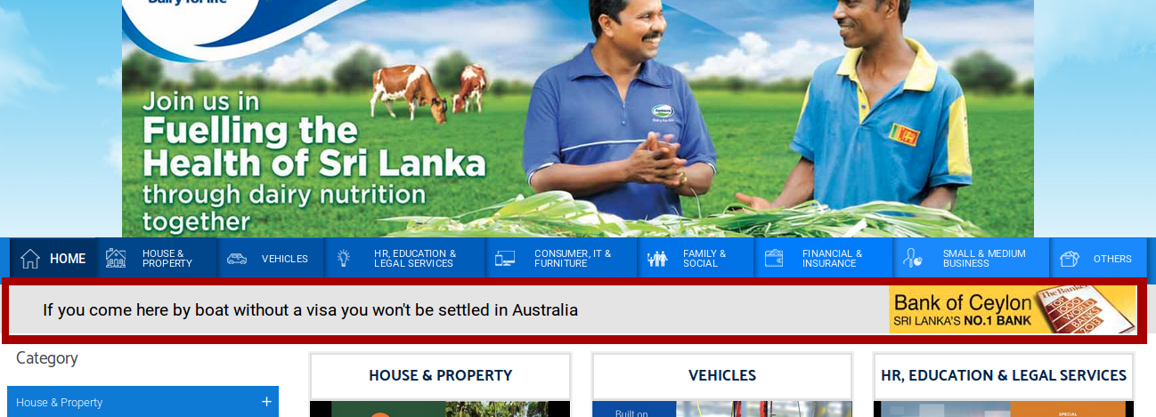
Fig. 4.13 – Display of Instructions (W275 x H55) on Home page
In order to access Instruction image adding process in backend, go to the extensions component into that select a dropdown called module to access following highlighted module to find out.
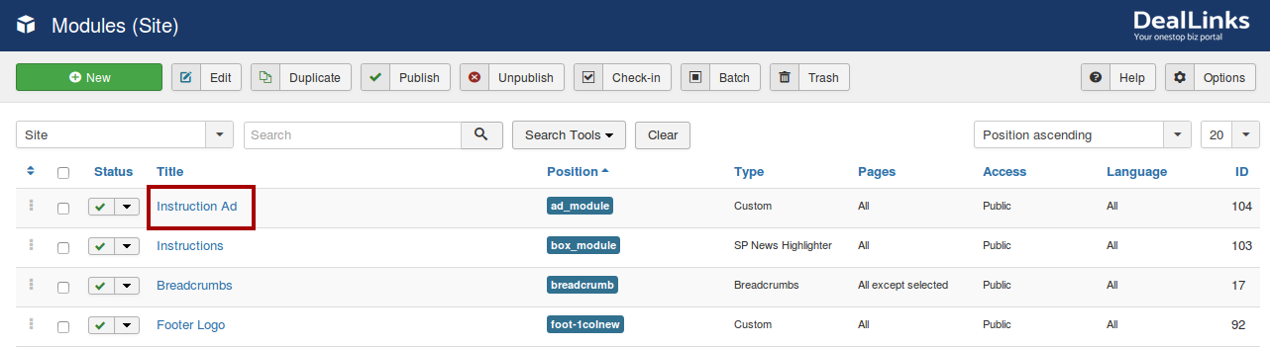
Fig. 4.14 – Display of Instructions add (Image)
Once you click on it, the related Image will be displayed on edit screen.
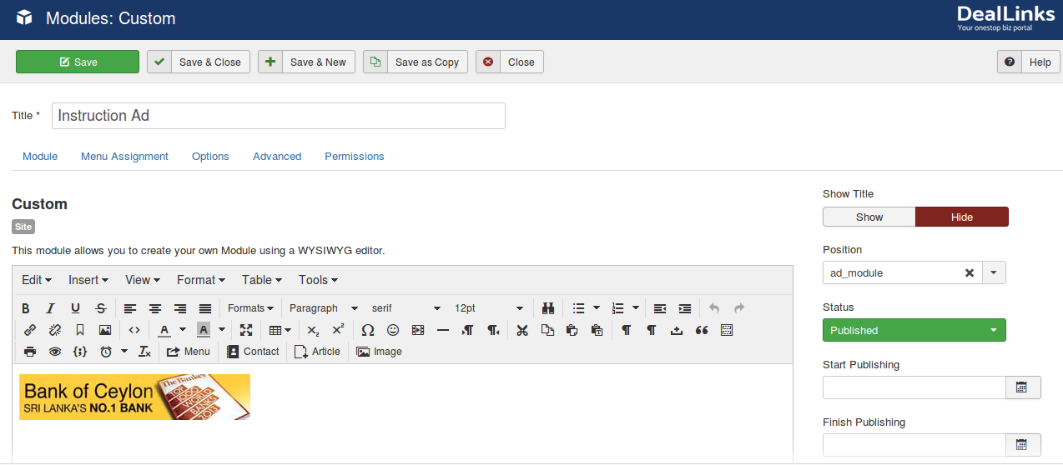
Fig. 4.15 – Display of Instructions add (Image) edit screen
In order to access Instructions adding process in backend, go to the extensions component into that select a dropdown called module to access following highlighted module to find out.
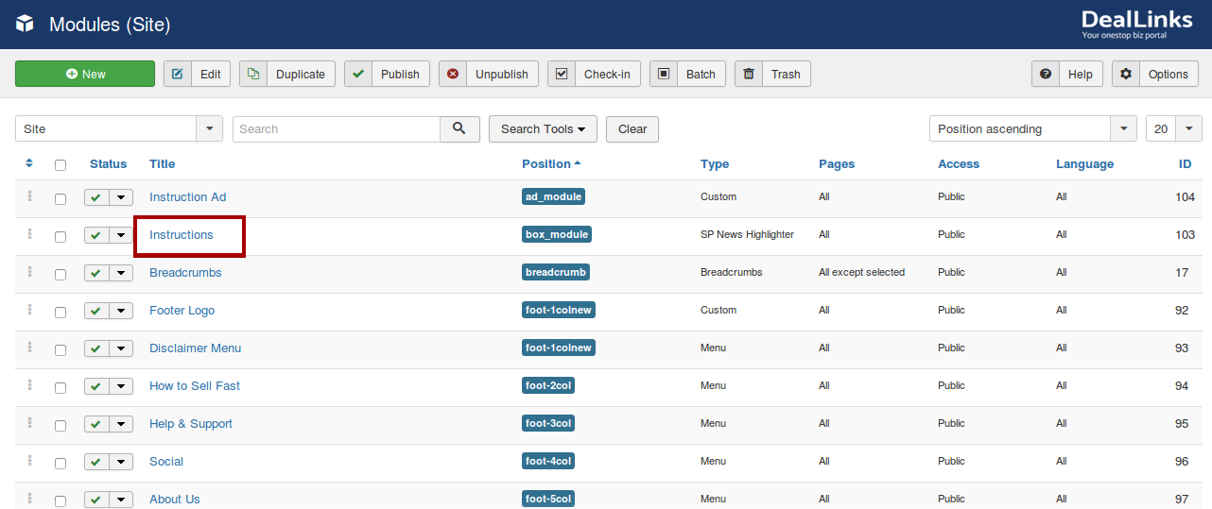
Fig. 4.16 – Display of Instructions Module
Once your selection has made, you will be able to access following screen (4.17).
Here you should select related “Category Blog” which contains a package of Article Instructions.
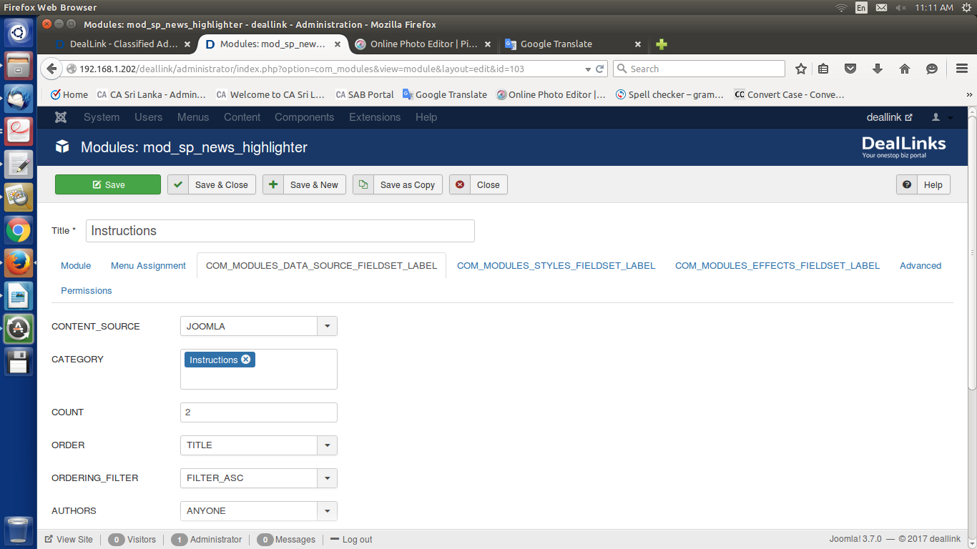
Fig. 4.17 - Display of Category selection
Once it all done, simply click on a button called “Save” to confirm your feeds.

